Mesa Community College Cheer Team tryouts

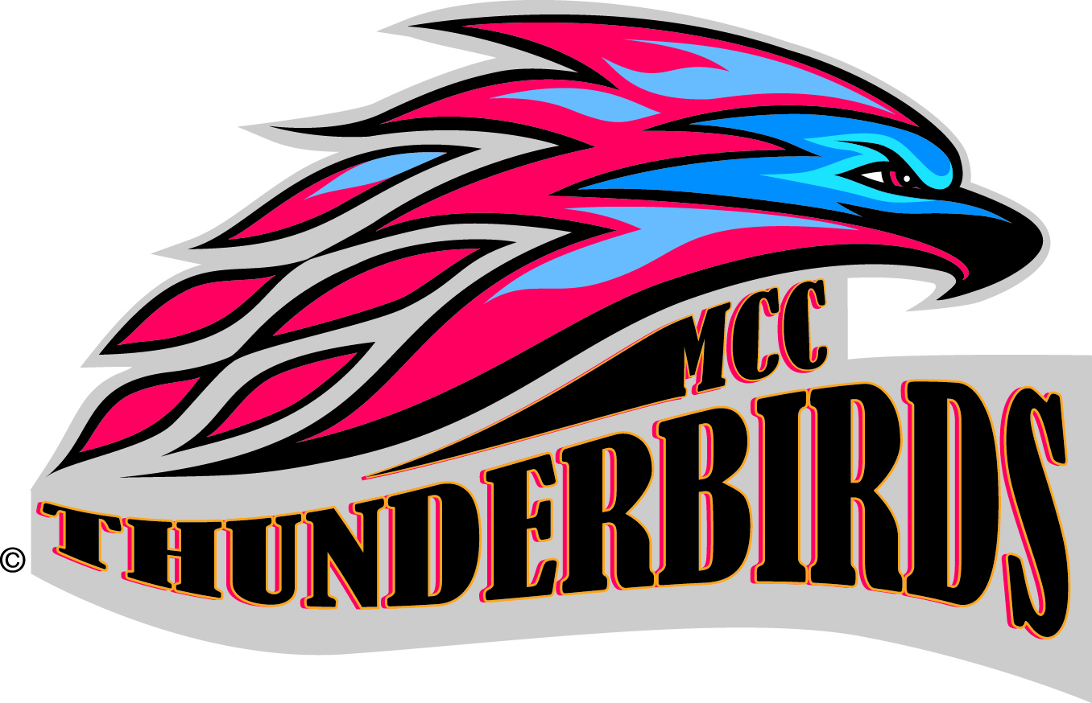
1

Cheer Tryout Application Packet Should Include:
Please bring all of the required documents on May 17th. Without these documents you will not be able to tryout.
- Completed Application
- Completed Statement of Understanding
- Current High School or College Transcript
- Two sealed letters of recommendation. (current coach, teacher, employer etc.)
- 4 x6 headshot

2016 Cheer Team Tryout Application
Application due: Monday, May 17th at the first clinic
Personal Information (please print or type)
Last Name ________________________________ MCC Student ID # __________________________
First Name ________________________________ Date of Birth ______________________________
Middle Name ______________________________ Home Phone ( _____) _______________________
Gender ___________________________________ Cell Phone (_____) _________________________
Permanent Address: Student email Address:
_________________________________________ __________________________________________
_________________________________________ (must be able to access throughout year)
City ______________________________________ *updates will be sent via email/fb page
State __________________ Zip ________________ Emergency Contact Name:
------------------------------------------------------------
Who is your employer? _________________________________________
__________________________________________ Emergency Contact Number:
__________________________________________ _________________________________________
__________________________________________ Insurance Company: ________________________
_________________________________________
Policy # __________________________________
Submit a photo copy of the front & back of your
insurance card
Size Information (xs, s, m, L, XL)
(Does not affect tryout score – used for new squad ordering purposes)
T-Shirt ____________ Warm-Up Jacket __________
Shorts/Briefs_________ Warm-Up Pant ___________
Height ____________ Weight ______________

History
Fill in any that apply: where you have cheered/danced & include number of years. This section will NOT affect tryout score. If none leave blank.

High School: _______________________________ All Star Team/Gym ________________________

_________________________________________ ________________________________________

College: __________________________________ Competition Experience: ____________________

_________________________________________ ________________________________________

_________________________________________ ________________________________________

Academic History: (include a current, official High School or College Transcript)

High School GPA ________ College GPA ________ College Status: fall/16 Fr So Jr Sr
Probable/Current Major: _____________________________________________________________
Skills:
Tumbling:
- Do you have tumbling experience?
- What is the highest level tumbling pass you can perform?

Stunting: flyer
- Have you been a flyer before?
- What stunts have you flown?

- What is the highest level skill achieved?

Stunting: BASE
- Have you been a base before?
- What stunts have you based?
- What is the highest level skill achieved?

Dance ability
- What dance training have you had?

Workout:
- Have you ever been on a workout program before? Explain.

- Is working out something you are physically capable of?

Interview Questions:
- Why did you choose MCC Cheer?

- What qualifies you to be an MCC Team Member?

- What skills do you bring to your current team?

- Have you ever been in a Leadership/Captain position? Explain.

- In fifty words or less tell us why we should choose you as an MCC Cheer team member.
(please attach)

Mesa Community College Cheer Team Statement of Understanding

I hereby certify that I fully understand the following:
- Cheerleading/Dancing involves a variety of gymnastics, motions, partner stunts, rotations and heights, therefore, participating in cheerleading/dance involves some amount of danger of personal injury. I totally assume the risks involved by participating in the 2016 tryouts. I further realize that improper conduct of cheerleading/dancing activity could result in catastrophic injury, paralysis or even death, therefore, I agree to abide by all AACCA Safety Rules and Regulations.

- I hereby certify that I have read, am thoroughly familiar with and will carefully abide by the American Association of Cheerleading Coaches and Advisors (AACCA) guidelines for safety in college cheerleading.

- I further agree to hold harmless the Mesa Community College Athletic Department, officers, directors, staff and spirit team officials for any injury which I may incur by being a participant in the cheerleading/dance tryout clinic and tryouts.

Medical Insurance Company and Policy Number:

STATEMENT: I have read carefully this memorandum, and I understand and accept the information and requirements contained in it.

Signature _______________________________________________ Date _____________________________

If under the age of eighteen years old a parent or guardian’s signature is required.

Signature ________________________________________________ Date _____________________________

